 Rum River Canoe Trip (Half-day)

Preparation
- At least one adult leader must take the on-line Safety Afloat training through my.scouting.org
- Everyone on the trip must wear a Personal Floatation Device (PFD) at all times.
- Canoes can be rented at Rum River Scout Camp through the Northern Star Council website. Canoe rental is $15 per canoe per day, including paddles and PFDs. Canoe trailer rental is $25 per day. When renting a trailer, the unit needs to rent at least half of the trailer full of canoes, to insure there are enough trailers for others that need canoes. Trailers hold up to 6 canoes.
- Swimming Ability – Every participant who intends to train for or paddle a solo kayak or canoe at a Scouting function must be classified as a swimmer by completing the 100-yard BSA swimmer classification test. For activity afloat, those not classified as swimmers are limited to multi-person craft during outings or float trips on calm water with little likelihood of capsizing or falling overboard. They may ride as a buddy in a tandem paddlecraft with an adult swimmer skilled in that craft.
- Canoeing Ability - Participants should have basic canoeing skills before paddling down rivers. Even if your troop is not camping at a Council camp, you may be able to rent the canoes there to practice on a local lake.
- Float Plan - Before Scouts go afloat, they develop a float plan detailing their route, time schedule, and contingency plans and share it with someone not on the trip. The float plan considers all possible water and weather conditions and all applicable rules or regulations, and is shared with all who have an interest.
- Water Levels - Most springs, the water level can be quite high. During normal water levels, the Rum River flows 1 - 3 mph. During high water, it can also get pretty fast (~6mph). Some landings (especially Rum River Central Park) cannot be reached by car during high water. There are occasionally tree limbs sticking into the river. These can be dangerous for inexperienced canoers. Consider scheduling trips when the water is not high.

The TRIP
- Meet at Rum River Scout Camp. You can reserve overnight camping or cabins through the Northern Star Council website.
- At least one vehicle will have to be left at Rum River Scout Camp so plan your rides accordingly
- One vehicle must be capable of pulling the trailer loaded with canoes.
- Turn right(North) on St. Francis Blvd (Hwy 47). Turn right on 179th Lane NW (County 27). Continue across Roanoke St NW into Rum River Central Regional Park and go to the Rum River North Public Water Access (approximately river mile 14). There is a large parking lot near the canoe landing. There is a park fee for entrance.
- The takeout is at Rum River Scout Camp on the right bank at approximately river mile 7 on the DNR river map.

More information on the Rum River
https://www.dnr.state.mn.us/watertrails/rumriver/index.html
Avenza Maps (Avenza Systems Inc) is a very nice free off-line mapping program which can download the same maps as above. After downloading the application and maps, a data connection is no longer needed. After downloading the Avenza program, you need to click on the ‘Store’ link in the app, and search for the map: Rum River State Water Trail. The correct maps are published by the Minnesota Department of Natural Resources. These are very handy when trying to determine distance remaining. These maps show the same river mile markers as the printable maps.

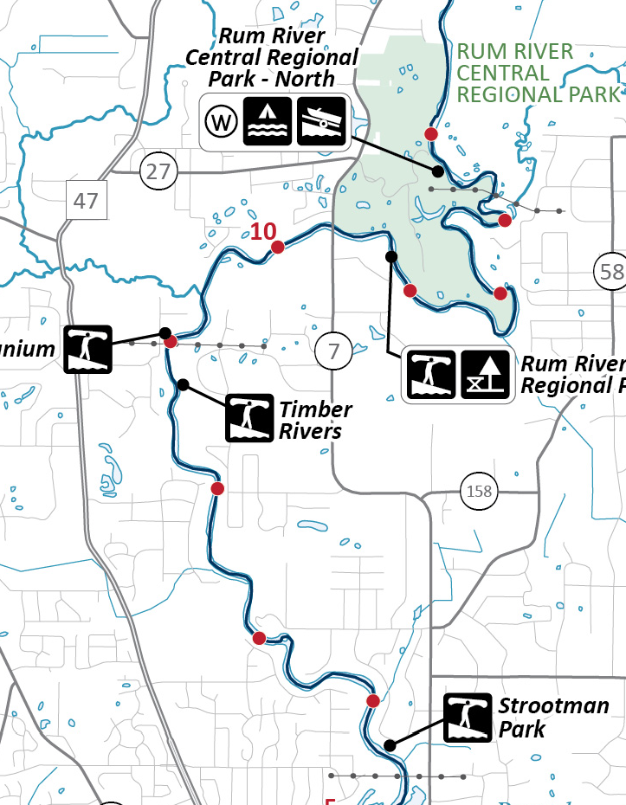
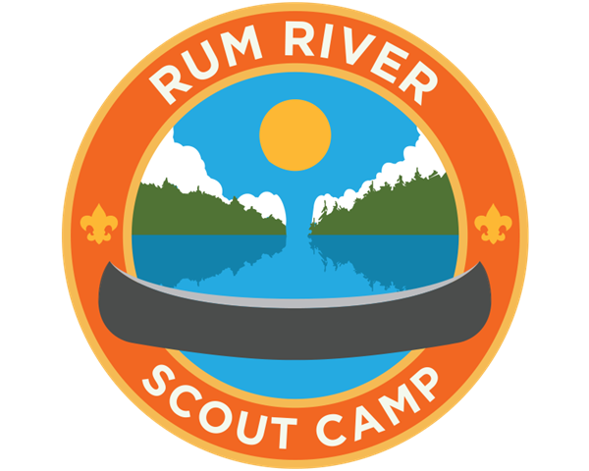

Rum River Canoe Trip (Full day)

Preparation
- At least one adult leader must take the on-line Safety Afloat training through my.scouting.org
- Everyone on the trip must wear a Personal Floatation Device (PFD) at all times.
- Canoes can be rented at Rum River Scout Camp through the Northern Star Council website. Canoe rental is $15 per canoe per day, including paddles and PFDs. Canoe trailer rental is $25 per day. When renting a trailer, the unit needs to rent at least half of the trailer full of canoes, to insure there are enough trailers for others that need canoes. Trailers hold up to 6 canoes.
- Swimming Ability – Every participant who intends to train for or paddle a solo kayak or canoe at a Scouting function must be classified as a swimmer by completing the 100-yard BSA swimmer classification test. For activity afloat, those not classified as swimmers are limited to multi-person craft during outings or float trips on calm water with little likelihood of capsizing or falling overboard. They may ride as a buddy in a tandem paddlecraft with an adult swimmer skilled in that craft.
- Canoeing Ability - Participants should have basic canoeing skills before paddling down rivers. Even if your troop is not camping at a Council camp, you may be able to rent the canoes there to practice on a local lake.
- Float Plan - Before Scouts go afloat, they develop a float plan detailing their route, time schedule, and contingency plans and share it with someone not on the trip. The float plan considers all possible water and weather conditions and all applicable rules or regulations, and is shared with all who have an interest.
- Water Levels - Most springs, the water level can be quite high. During normal water levels, the Rum River flows 1 - 3 mph. During high water, it can also get pretty fast (~6mph). Some landings (especially Rum River Central Park) cannot be reached by car during high water. There are occasionally tree limbs sticking into the river. These can be dangerous for inexperienced canoers. Consider scheduling trips when the water is not high.

The TRIP
- Meet at Rum River Scout Camp. You can reserve overnight camping or cabins through the Northern Star Council website.
- At least one vehicle will have to be left at Rum River Scout Camp so plan your rides accordingly. One vehicle must be capable of pulling the trailer loaded with canoes.
- Turn right (North) on St. Francis Blvd (Hwy 47) and follow your navigation directions to Rum River North County Park, 23100 Rum River Blvd NW, St Francis, MN.
- Launch at the canoe launch (approximately river mile 23). There is a large parking lot near the canoe landing.
- The takeout is at Rum River Scout Camp on the right bank at approximately river mile 7 on the DNR river map.

More information on the Rum River
https://www.dnr.state.mn.us/watertrails/rumriver/index.html
Avenza Maps (Avenza Systems Inc) is a very nice free off-line mapping program which can download the same maps as above. After downloading the application and maps, a data connection is no longer needed. After downloading the Avenza program, you need to click on the ‘Store’ link in the app, and search for the map: Rum River State Water Trail. The correct maps are published by the Minnesota Department of Natural Resources. These are very handy when trying to determine distance remaining. These maps show the same river mile markers as the printable maps.

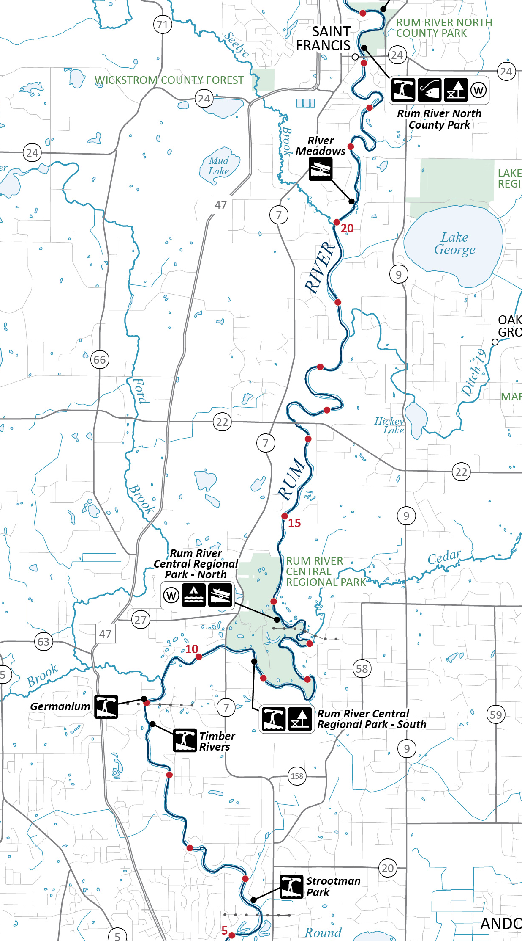
Rum River Canoe Trip (Overnight)

Preparation
- At least one adult leader must take the on-line Safety Afloat training through my.scouting.org
- Everyone on the trip must wear a Personal Floatation Device (PFD) at all times.
- Canoes can be rented at Rum River Scout Camp through the Northern Star Council website. Canoe rental is $15 per canoe per day, including paddles and PFDs. Canoe trailer rental is $25 per day. When renting a trailer, the unit needs to rent at least half of the trailer full of canoes, to insure there are enough trailers for others that need canoes. Trailers hold up to 6 canoes.
- Swimming Ability – Every participant who intends to train for or paddle a solo kayak or canoe at a Scouting function must be classified as a swimmer by completing the 100-yard BSA swimmer classification test. For activity afloat, those not classified as swimmers are limited to multi-person craft during outings or float trips on calm water with little likelihood of capsizing or falling overboard. They may ride as a buddy in a tandem paddlecraft with an adult swimmer skilled in that craft.
- Canoeing Ability - Participants should have basic canoeing skills before paddling down rivers. Even if your troop is not camping at a Council camp, you may be able to rent the canoes there to practice on a local lake.
- Float Plan - Before Scouts go afloat, they develop a float plan detailing their route, time schedule, and contingency plans and share it with someone not on the trip. The float plan considers all possible water and weather conditions and all applicable rules or regulations, and is shared with all who have an interest.
- Water Levels - Most springs, the water level can be quite high. During normal water levels, the Rum River flows 1 - 3 mph. During high water, it can also get pretty fast (~6mph). There are occasionally tree limbs sticking into the river. These can be dangerous for inexperienced canoers. Consider scheduling trips when the water is not high.

The TRIP
- Meet at Rum River Scout Camp. You can reserve overnight camping or cabins through the Northern Star Council website.
- At least one vehicle will have to be left at Rum River Scout Camp so plan your rides accordingly. One vehicle must be capable of pulling the trailer loaded with canoes.
- Turn right(North) on St. Francis Blvd (Hwy 47). Follow navigation to the put in at Martins Landing in Isanti, MN(approximately river mile 35). There is a large parking area near the canoe landing.
- Camp at the Rum River Central Regional Park North Landing(approximately river mile 13). You can carry your camping gear with you or have another vehicle meet you at the campsite.
- The takeout is at Rum River Scout Camp on the right bank at approximately river mile 7 on the DNR river map.

More information on the Rum River
https://www.dnr.state.mn.us/watertrails/rumriver/index.html
Avenza Maps (Avenza Systems Inc) is a very nice free off-line mapping program which can download the same maps as above. After downloading the application and maps, a data connection is no longer needed. After downloading the Avenza program, you need to click on the ‘Store’ link in the app, and search for the map: Rum River State Water Trail. The correct maps are published by the Minnesota Department of Natural Resources. These are very handy when trying to determine distance remaining. These maps show the same river mile markers as the printable maps.

